Name: OVIYA M D
Reg no: 1P25CS010
Subject : Business intelligence using Pentaho

SQL – Assignment-1

A.Find the total and the average sales (display total_sales and avg_sales).

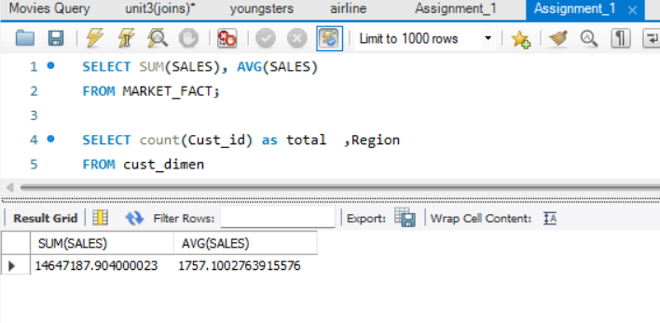

B. Display the number of customers in each region in decreasing order of
no_of_customers. The result should contain columns Region, no_of_customers.

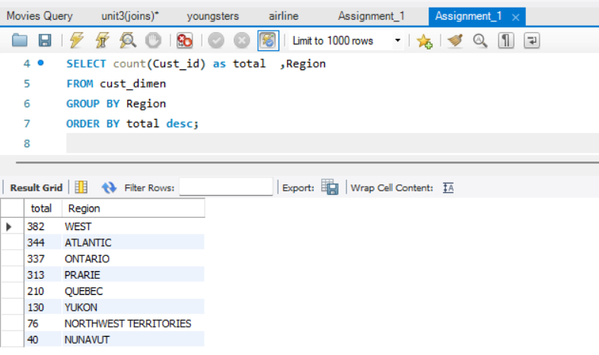

C. Find the region having maximum customers (display the region name and
max(no_of_customers).

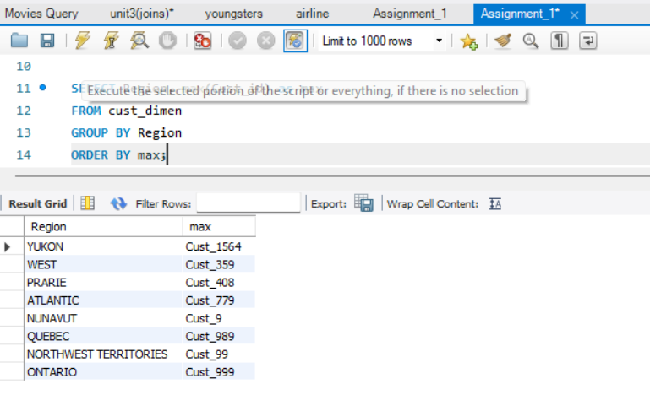

D. Find the number and id of products sold in decreasing order of products sold
(display product id, no_of_products sold).

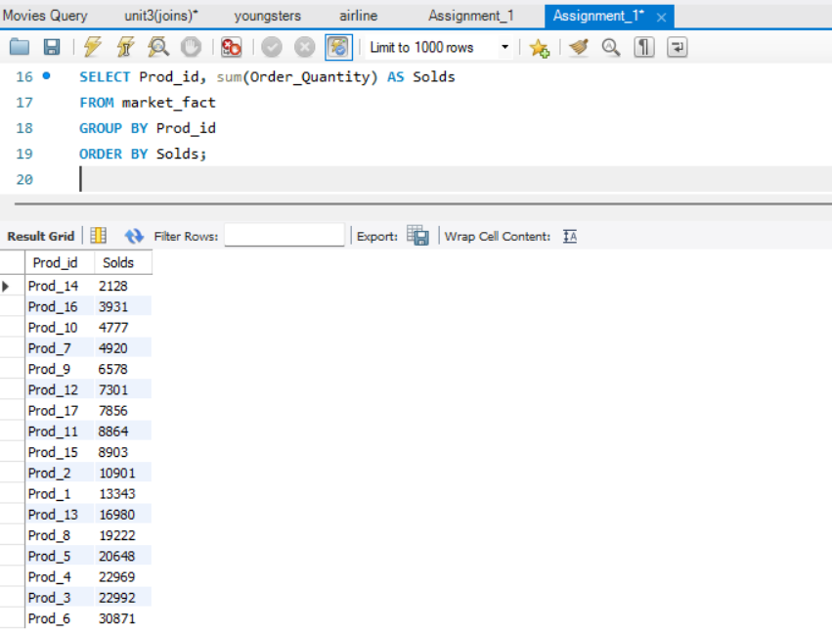

E. Display the product categories in descending order of profits (display the product category wise profits i.e. product_category, profits)?

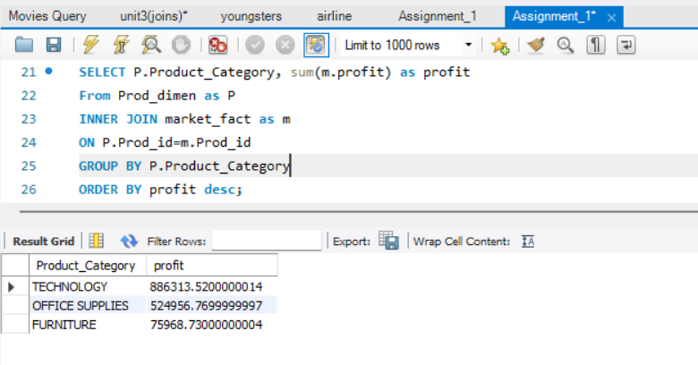

F. Display the product category, product sub-category and the profit within each sub-category in three columns.

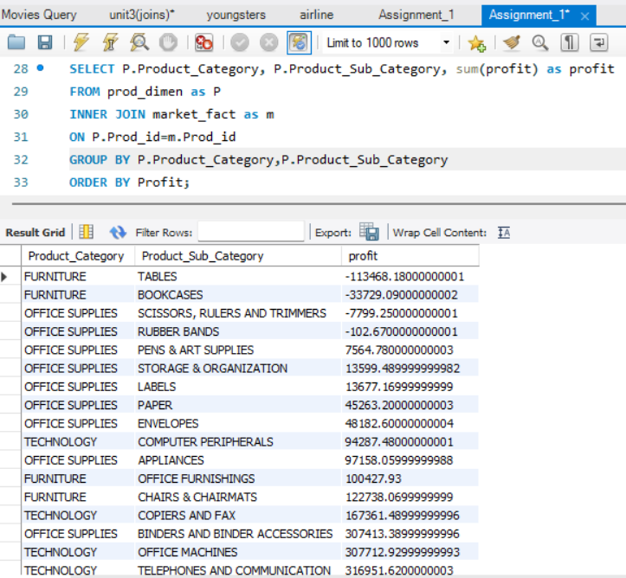
G. Find all the customers from Atlantic region who have ever purchased ‘TABLES’and the number of tables purchased (display the customer name, no_of_tables
purchased).

